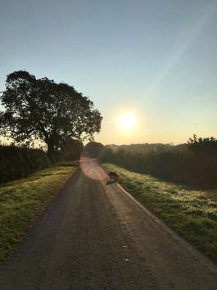

The Newsletter for Middleton on the Wolds

Issue No 30

SEPTEMBER

2021

NEXT COPY DATE
14th September

As well as the interesting articles sent in by residents of the village, I want to remind you that there are 2 advertising features at the back of each Messenger
which change every month. It is interesting to read what is happening in the 2 local firms, Black Yak with information about life in Nepal and Soanes Poultry who this month are sponsoring a young kart driver.
Did you miss Yorkshire Day? Well I did! Apparently it was on Sunday 1st August. If you would like to celebrate belatedly you might like to have a go at the 2 quizzes sent to me by Sarah Hutchinson at East Riding. She was “delighted” when I asked if I could include them in the Messenger.
Please send in your contributions to middletonflyer@yahoo.com by the end of the copy day. If I don’t acknowledge them please get in touch to make sure they have arrived.
Lyn
4 The Paddocks 219500
ADVERTISING COSTS for the Messenger
Rates Month Year

Whole Page £25 £150

1/2 Page £15 £100

1/3 Page £10 £60
Full colour - Print run 500 copies
Contact: Tina 01377 217242, middletonflyer@yahoo.com

Editorial
I’ve already said a few times that when I write in the Messenger I do so as an individual, not as a parish councillor. This still holds true now I am chair of the council and, this month, I want to clear up any confusion about what the Messenger is and what its links are to the Parish Council.
After a ‘frank and forceful exchange of views’ in a council meeting we agreed that The Messenger is financially accountable to the PC, this is, after all, where our funding comes from. On the other hand, all content, publishing, distribution and advertising is operated and managed by a management team made up of me, Tina Walker and Lyn Dennis. (Details are in July 2020 PC minutes on www.middletononthewolds.co.uk).
‘Ah’, I hear you say, ‘but two of the team are parish councillors, surely there is a conflict of interest, here.’ I agree that this is a potential danger and all I can do is ask you to trust me when I tell you that the team jealously guards its editorial independence.
I’m banging on about this because, this month, we have published two letters which would have been better addressed to the PC. The replies to these letters have come from the PC, not from me as editor. We are more than happy to publish such letters and responses because it opens up issues for public discussion. I do, however, want to emphasise that the PC and the Messenger are separate entities, especially in terms of what is written in the newsletter.
And finally, there was no editorial last month. I would like to say sorry but, hey, I was having a great holiday and just didn’t have the time to write it.
Stay safe.
Mike

If you have any ideas, comments or complaints (especially complaints) you want to share then send an email to middletonflyer@yahoo.com.
Remember, we can’t respond unless we receive your message.

correspondence
Some years ago I thought it would be nice to have an allotment but they were far too large and I doubted I would have the time or enthusiasm to devote to keeping it pristine. Eventually I arranged with the PC to have a half share with one other. This worked well and I had enough land to provide far more than I needed for my household and was constantly giving veg away to others. Even half of an allotment took a considerable amount of time and effort even though I was retired.
Look at it like this – if you had an extremely large garden and wished to grow vegetables, I doubt you would set aside the amount of land the allotments have.
If someone wants to spend the energy to keep the allotment in reasonable condition, all well and good, but I gather there is a waiting list and that some of the plots are not that well maintained.
Would it not therefore be sensible that, where this is the case, half of the land is shared with someone on the list, enabling the following
Someone that wants an allotment gets one
It relieves the burden of work for the existing holder
The condition of the allotments is improved Just a thought!
Arthur Conduit
A good idea, Arthur, which I’m sure the Parish Council will take into account!
Kennel Cough
Kennel cough is rife among our canine friends at the moment. It is easily spread from droplets from the mouth and nose. It can also be spread from clothing and vegetation.
Protection can be given by your vet. In healthy dogs it usually doesn’t cause severe illness but, for young, old and vulnerable dogs can be serious.
If you have a dog with kennel cough, or one that has been in contact with an affected dog, please keep them at home; do not walk them out, even on a lead. Treat the problem as you would COVID 19. Isolation, for at least 10 days, is essential to stop this problem from spreading.
These measures are part of responsible dog ownership.
Sheelah Bamford

correspondence
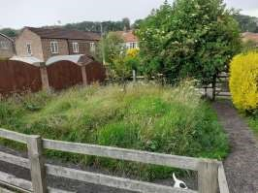

According to Councillor Wilson
-
Dodd. This is an experiment, if successful
it will be repeated around the village. The question is who decides what
success is, and do the residents of the village get a say.

J.Wales

The parish Council has given the following reply:
It is the duty of the Parish Council to make best use of village assets. With this in mind we are doing a trial on a small piece of parish council land to support the current push for leaving open spaces as pollinating areas as part of the government’s stance on reducing carbon pollution.
Decisions and actions are taken and agreed by the Parish Council, not by individual councillors and, while it would be impractical to run every decision past everyone, we welcome views from residents, on whether they like or dislike this idea, and whether they would like to see grass verges and open spaces sown with wildflowers and grasses. These views will, of course, inform our future decisions.

QUIZ PAGE
- Who wrote War of The Worlds?
Which Wimbledon champion appeared in the 75th anniversary issue
- of the Beano?
- Mr Wickham is a character in what Jane Austen novel?
- What's the only Portuguese speaking country in South America?
- What's the largest city by population in Germany?
- What's the occupation of Peter Parker the alter ego of Spider-Man?
- The mouth of the River Tweed is in what country?
What Zodiac Sign is represented by a maiden carrying a sheaf of
- wheat?
Which celebrity chef opened the Union Jack's restaurant in Covent
9
Garden?
10 James Browns first UK hit was "Papa's Got A Brand New what?
Quiz set by Rowland Wooldridge

SUDOKU
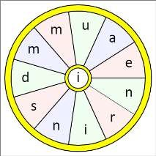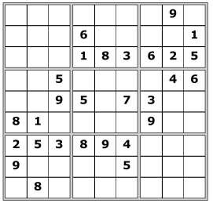
All answers on
page 23

SEASONAL WORD WHEEL

Try and find the 2 words, then make
as many words of any length as you
can from these letters. You can only
use each letter once, and each word
must include the letter

I

Yorkshire Quiz general questions
Answers on page 23

- Which is the largest city in Yorkshire?
- To which Saint is York Minster dedicated?
- Which THREE British Prime Ministers were born in Yorkshire?
- In which Yorkshire city would you find the Ferens Art Gallery?
- Which TWO National Parks lie largely in Yorkshire?
- What flower is the symbol of Yorkshire?
- Which Yorkshire race course is the largest circular flat course in Europe?
- Which National Museum was established in York in 1975?
- Which inn in North Yorkshire is said to be Britain’s Highest Public House?
- What did Harry Brearley invent in a Sheffield laboratory in 1913?
- In which Yorkshire town was the original Harry Ramsden’s fish and chip shop located?
- Although they are always associated with Haworth, in which Yorkshire village were the Bronte sisters born?
- Which Yorkshire village was home to the World’s longest running TV Sit-Com?
- What was the Roman name for York?
- In which Yorkshire town was slavery abolitionist William Wilberforce born?
- Yorkshire was originally split into three “Ridings”, from which language does this come?
- What is the traditional nickname for a Yorkshireman?
- Home to Britain’s first IMAX cinema, which Yorkshire city houses the National Media Museum?
- At which Yorkshire location was the first lighthouse in Britain built in 1427?
- In which Yorkshire town was Rugby League formed in 1895?
St Andrew’S church

Services for September

Sunday 5th. Sept. Morning Prayers. At 10.30.a.m. C/W

Sunday 12th. September. Joint worship at 10.30.a.m. Rev`d Jane Anderson

Sunday 19th. September. Holy Communion at 10.30.a.m. Rev. Canon Kate
Goulder.

Sunday 26th. September. Holy Communion at 10.30a.m. Rev`d Ruth Newton

Please note. Other services.

Sunday 29th. August. Benefice Holy Communion at Kilnwick.10.00.a.m.Rev,d Canon Kate Goulder.

There will NOT be a service at St. Andrews, Middleton on Sunday October 3rd.

The wolds METHODIST CHURCH bainton

Services for September
Sunday 5th 10.30am | Service at the Wolds Methodist Church,
Sunday 12th 10.30am | Thanksgiving service at the Wolds Methodist
 | Church, Mr Hector Robinson
Sunday 19th 10.30am | Service at the Wolds Methodist Church,
 | Worship Group 1
Sunday 26th 10.30am | Service at the Wolds Methodist Church,
 | Mr Peter Rogers
A NOTE FROM YOUR VICAR

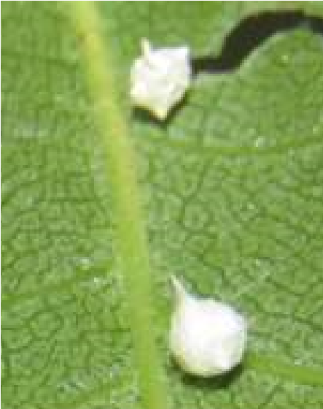
A SAINT FOR ALL CREATURES
Last week I was cleaning the windows at the Rectory, this is a job I am not very good – the glass always looks streaky no matter what I use. I also worry about squishing the spiders which take up residence (outside not indoors) in the very corner of the window frames, and that’s what almost happened last Monday.
As I whizzed around with my trusty wet and dry eco cloths I accidently opened one of those white silken egg sacks (spiders can produce between 10 and 20 of these in their life time – each containing between 150
– 300 eggs) The spider fell out and ended up on the window sill. As I watched her, she attempted to climb back up the frame, but it was wet and she couldn’t cling to it. Carefully I put the cloth just beneath her, half expecting she would scurry away, but she didn’t. Instead, she stood on the cloth as I lifted her back to the sack, where she scurried inside and began to repair the damage I had done.
Seeing this little creature struggling to return to her ‘nest’ and her reaction when she returned was very moving. It made me wonder if there is a Patron Saint of spiders – there is!
St Felix of Nola, near Naples. He belonged to a wealthy family but when his father died he gave all of his inheritance to the poor. He was ordained by Bishop Maximus, whose assistant he became. However, when Decius became Emperor, he began to persecute the Christian community. Maximus went into hiding and Felix was imprisoned and tortured in his stead.
Legend tells that Felix was released from his cell by an angel. The Roman soldiers gave chase and Felix hid himself in a small cave – seeing he was such a good man, the spiders took pity on him and spun a large web over the opening so that the soldiers would think it had been empty for some time (a similar legend is told about the Holy Family when they were fleeing from Herod’s soldiers) So Felix is often depicted with a spiders web. His Feast Day is 14th January and he is patron saint of spiders, Nola his home town and spider keepers.
Until next month.

Take care
Jane

Local Birds & wildlife
Well, time for the end of the experiment. ‘No Mow May’ extended into June and July for us, but as time went on the flowers got fewer, and the long grass flopped over in the rain and started dying from the ground up. We were interested to notice that the birds were happiest pottering up and down the mown paths, and they stopped using the bird bath once it was surrounded by long grass –
Marsh harrier presumably they had an instinctive feeling that predators could be sneaking up on them unseen. I think we might do
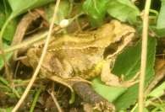
it again next year as the profusion of flowers in May and June was a real surprise, and there were lots of hoverflies and bees taking advantage of them, but obviously the law of diminishing returns kicks in, and we won’t carry it on for so long.
There was one creature that enjoyed the experiment though; Ian took this picture of a frog who obviously found our garden more acceptable in that state – we hadn’t seen a frog in the garden for a very long time before this!
Pat has a bit of help in keeping her long grass down: “We have two new lodgers in our wildlife garden, impossible to keep nice with
two ducks living in it, two baby bunnies who have grown considerably since they moved in. Living under my shed we think. Keeping the long grass down for us.” Let’s hope the two of them are the same sex, or very soon there will be even more grass-mowing assistance! She continues: “Also have nesting house martins; must be about ready to go hopefully. What a mess they make. Love having them though. The red kite keeps making an appearance above us flying very low showing off all its wonderful colours. Never tire of seeing birds of prey, my favourites. Still occasionally see the pied wagtails, one on
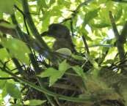
Tina’s ridge tiles the other day. No more visits from the owls though!”
Tina invites us to “Meet George, our baby pigeon!” He looks very content tucked up in his shady nest and I felt rather jealous when I looked at the picture on a very hot day.
Sheelah is sorry that the blackbird family with young have now stopped visiting her garden as have a mother and baby thrush. However she had a huge compensation for this when a marsh
harrier flew over her garden! Apparently it was also seen on another day over Orchard Drive, so it just goes to show it’s really worth keeping a good look around whenever you are outdoors round here! If you venture further afield, she reported that “I have a friend who is a volunteer at Bempton. In addition to Albert (the black-browed albatross) (Albert Ross!) she saw a black stork last Saturday.”
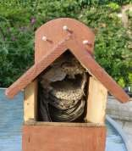
Finally Lyn has taken this picture of a vacated wasps’ nest in a robin’s nesting box. Was it vacated voluntarily I ask myself – though much as wasps are good for the garden they really have to be dealt with very firmly if the nest is in a situation where the gardener is going to be regularly ambushed – with painful results – or where innocent passers-by are going to get a nasty shock. Perhaps this is a good moment to mention that the internet is full of helpful advice about dealing with nests, and other less helpful advice such as pouring petrol on them and tossing a match in!
Please let me know about any interesting sightings you have, and of course it is always lovely to have pictures to put in.
Barbara (lavenderbarbara97@gmail.com or text 0777 192 7868)

Friday 24th September

Plans are in progress for the annual Macmillan Coffee Morning which
will be held in the Village Hall. Please look out for details of times etc on
posters or ask Emma at Wolds Waves or Hazel Kazer.

Donations of raffle prizes, bring and buy etc will be much appreciated.

There will be a collection box in the Post Office for donations
from anyone who would like to support this amazing and very
necessary charity

LOCAL HISTORY
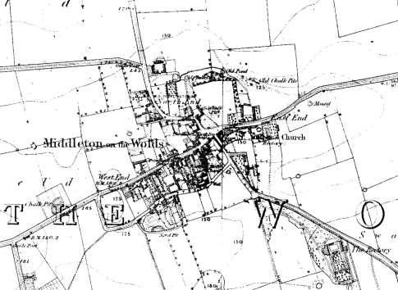
AN EARLY RECTORY

In a “terrier”, that is a list of land, made in 1861 reference was made to “ the parcel of ground called “Colly Garth” together with a garden and orchard belonging to the said rectory and held in copyhold of the Manor of Middleton to a copyhold which is paid every half year of 6 pence for the said Colly Garth and garden to the Duke of Devonshire and was the benefaction of Mrs Elsie Crouch daughter of the late Revd Crouch formerly rector of this parish.”
This land would appear to correspond to that shown on the OS map of 1855 as an area with trees and a footpath to the Beverley Road which today is Soanes Poultry Unit but on which, back in 1685, the then rector Matthias Crouch listed “ a parsonage house completely repaired and one garden and one orchard copse planted by the present incumbent”.
In 1764 Christopher Spencer Brearey the then incumbent gave details of a quite intriguing property: “To the said Rectory belongs one Manse or dwelling house the body 21 yards long and 7 broad with a wing extending from the north west part 4 yards and 1 foot which is in breadth 6 yards and 6 inches covered with straw containing a large kitchen, an hall, a parlour and several small offices below stairs and 2 cellars, the rooms are run with lime and hair and whitened over, the parlour is papered. Above stairs are 5 small rooms all papered and boarded. To the said Manse adjoin 2 stables and a coach house with garner over them; a large barn of 6 bays and a garden before the house and an orchard behind. Also adjoining to the foldyard of the said Manse lays a lesser foldyard called Collygarth which has in it a lesser barn of 3 bays which has a right of corn monage belonging to it having been formerly a Crafts house together with a garden or orchard lying to the south of them belonging to the said Rectory in copyhold of the Manor of Middleton, a copyhold rent of 1 shilling being paid to the Lord of the Manor. There is a pigeon house and brewhouse.”
This rectory was demolished in 1809 when the replacement was built which later became The Hall. During the life of the earlier rectory the religious turmoil following the Reformation and the uncertainty of the Civil War gradually eased and by the eighteenth century complacency in the established church had set in so it is perhaps significant that the few illustrations of church services in that period often show most of the congregation almost asleep through boredom. For Archbishop Herring’s visitation to the parish in 1743 the practices of the then incumbent Christopher Spencer Brearey were recorded for the 39 families in the village when he boldly stated:
“I read the public service in my church every Lords-day in the morning and preach and read the public service in the afternoon. I catechize the children and servants (during the season of Lent) every Wednesday and Friday morning and on Sunday in the afternoon. I administer the Sacrament of the Lord’s supper in my church 4 times every year. I have about ninety communicants in my parish, 60 or 70 usually receive and I believe very near that number received last Easter. I give open and timely warning of the Sacrament before it is administered. My parishioners do not send in their names and indeed I have not required it. I have not refused the Sacrament to any one”. In a subsequent visitation in 1764 he boasted of 36 families in the village “in which thank God there is not a dissenter.” Christopher Brearey’s father Thomas, a man well connected enough to be buried in York Minster, had started what was to become the first of two dynasties each of three family members who succeeded each other as Rector in the village. This had been made possible with the power of family connections created by married clergy after the Reformation as was the holding of more than one living. The rector would have received a classical education (Greek and Latin) together with his religious studies making him the best educated person in the village. He together with the landowning class (who would most likely have occupied a separate section in the church) exercised the real power in the community.
Daily life in the rectory remains a tantalizing unknown. Was it benign like Parson Woodforde’s Norfolk home or the humorous Sydney Smith at Foston between Malton and York or the creator of that highly eccentric literary classic “Tristram Shandy” Laurence Sterne at Shandy Hall in Coxwold at the edge of the Howardian Hills? Probably not, but let us hope he treated his servants kindly in the slow moving world of the eighteenth century when simple pleasures were valued and contact outside the village was limited in that horse drawn age. The rector would have his select company of friends and his learned journals to read; his servants had to be content with distractions and an existence enlivened by the news reports from the market towns by the carrier, the itinerant pedlars, and gossip in the ale-house. Geoff Wisher obituary
In Remembrance of
Basil Clayphan
Basil was a stalwart of the village for many years, serving as a Church Warden at St Andrew's Church and also a Parish Councillor some of which was as the Chairman. He was well known around the Village, always open to discuss items with Villagers especially those which could be resolved by the Parish Council or point them in the right direction for answers.
Due to the present situation regarding restrictions many were unable to attend his funeral and would like to send their condolences to his immediate family and friends.
He will be greatly missed by all those who knew him in the village.

Reading rooms
COIN & MEDAL VALUATION

Wednesday 8th September
The team of expert valuers from the medal centre have been asked to return to Yorkshire, to run another series of their ever-popular Coin & Medal valuation days to help raise funds for Ex-service charities.
The experts from the Medal Centre are visiting six different venues over six days during the first week of September and they will be found at Middleton on The Wolds, Reading Rooms.
Open to the public from 9.30am to 4.30pm, everyone is welcome to be offered a free, no obligation valuation of their items and an immediate cash payment should they wish to sell.
The owner of the Medal Centre, Andrew Jukes is an expert in all forms of British campaign & gallantry medals and is a member of the Orders & Medals Research Society. He also has expertise in all forms of militaria with a passion for pocket watches and vintage watch chains. He is assisted by two members of his team of valuers who are experts in coins and bank notes, postcards, Masonic & R.A.O.B regalia along with swords, daggers & edged weapons, cloth & enamel badges & gold & silver coins.
Mr Jukes says he never fails to be surprised at the treasures that can be found in the attics of Yorkshire or at the back of sideboard drawers. After many years of valuations and making offers he is still thrilled at the amount of good quality items that can be found hiding in old tins and boxes. People should never be afraid to contact him or a member of his team for advice or a cash offer as often people are amazed at just offers for inherited or unwanted items. No item is too big or small for his team to handle and people are welcome to come along on the day with anything from a single medal to a complete collection. It is always important to remember to bring any original documents, paperwork, photos or boxes that came with the item as these can sometimes help to increase both the value and interest.
At the last series of events Mr Jukes was thrilled to be able to purchase a small box of gold and silver coins along with a group of war medals and bravery medals from a local soldier. However he was probably not as thrilled as the lady owner of the items who walked away from the event with a four figure sum!
Why not call in and see if you can raise some much needed extra cash and help the Ex-service charities in the process. No appointment is necessary and all you need to do is come along to be offered a no obligation immediate cash offer. The Medal Centre will be making a small donation to the Royal British Legion for every item that they are able to purchase on the day.
If you cannot attend on the day the Medal Centre is always happy to arrange a home visit or house-call to see you at your convenience. All you do is ring The Medal Centre in Hexham on 01434-606974 (shop) or 07950-421704
(mobile).

Parish council
COMMUNITY SPEEDWATCH
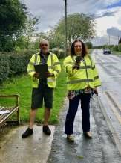
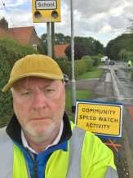
August saw the start of a Community Speed Watch within the village. Village Volunteers along with Parish Council members undertook training over the summer under the guidance of Humberside Police and Safer Roads Humber. The scheme aims to allow trained volunteers to address speed concerns within their communities and is a priority area in our Community Plan. It works alongside existing police speed reduction schemes but has an emphasis of raising awareness of speeding within communities and educating drivers about the dangers of speeding within residential areas, particularly near schools and other community facilities.
Data collected is used to inform the Police and others on the allocation of resources and general road safety issues. The team will be out throughout the rest of the summer and into the Autumn and a similar scheme now operates in North Dalton. Please help us by being aware of your speed whilst driving in our village and keeping within the clearly defined speed limits.

Thank you!

Nick Jones
Tina Walker
Peter Roe
On behalf of the Community Speed Watch Team

Recreation Ground Play Equipment Update
The new equipment should be in and finished by 20/08/2021.
There have been a few delays caused by bad weather.
I would like to say a big thank you to S.G. Prescott & Sons for their help unloading and transporting equipment up the field.
There will be a small opening ceremony on 18th September 2021. Everyone interested is welcome to come along and have a look at the new equipment especially the children who can try it out and give their opinions

Grand Opening Saturday 18th September 2.00pm to 3.00pm
There will be an official opening at 2.30pm, when the ribbon will be cut by Nigel Upson Managing Director of Soanes Poultry.
Come and see what activities the village has to offer for adults and children.
Representatives are attending from: -
Cricket Club, Recreation Club, Bowls Club, Middleton Movers, Book Group, Village Hall, Yorkshire Country Women, Speed Watch, Parish Council, First Responders.
Cllr Tina Walker

Middleton book group
The Summer seekers by Sarah Morgan . This book is one of the Sunday times top 5 bestsellers for 2021. Kathleen, an 80yr old sprightly lady is not yet ready for residential care, although her daughter thinks she is! And she is looking for an adventure Marta is having a midlife crisis and answers an advert to be Kathleens driver . They embark on a road trip across America and this is the story of all their ups and downs along the way. The perfect holiday read.

A Venice Sketchbook by Rhys Bowen. I found this a beautiful and also sad story, flipping from WW11 to the present day. I highly recommend this book to any others who love Venice as much as I do, Rhys Bowen’s grasp of description enables you to envisage exactly where the story unfolds, from the elegant palazzo on the grand canal to the dark beauty of San Stephano. A tale of a wartime romance that was kept secret for a whole generation. My favourite book of the year.
Pam
Next books for discussion: “State of the Union” by Douglas Kennedy
“The Country Girls” by Edna O’Brien

We are going back to meeting on a Tuesday afternoon, the next meeting being 14th September. To find out more about the Book Group please contact Lyn on 219500 or lyndennis456@gmail.com

Yorkshire Day quiz
–

Books set in Yorkshire

Can you guess these books which are all set (some just in part) in
Yorkshire? Answers on page 23

Each author
’
s initials are given as an extra hint.

1.

A young boy and his bird
–

by BH.

2.

C & H forever!!
–

by EB.

3.

A young man sets sail from Hull for the Carpathian Mountains
–

by
BS.

4.

Twelve months of the escapees
–

SS.

Village hall news
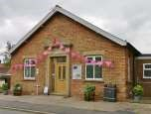
Legacy - You may remember that we were given a very generous legacy by Mrs Regina Bradley. We thought that villagers would like to know that the money has been used to refurbish the kitchen including the replacement boiler.
Afternoon Tea - The Village Hall Committee are going to hold an afternoon tea on Saturday 9th
October. The charge will be just £6.50 per head. Please look out for a poster on the notice board outside the hall for more details and get in touch with Sharon on 217254 or sroe.general@gmail.com or any of the committee to get your tickets.
Hall Hire - To hire the Village Hall please get in touch with Lyn on 219500 or lyndennis456@gmail.com. The cost is only £8 per hour with discount for 4 hours or a full day.
Help Required - As the committee is very small we welcome any extra occasional help. If you feel able to offer your services for example setting out tables and chairs for events or helping to serve teas we would be pleased to hear from you. It would help us greatly to have a few names and phone numbers to call if needed.
We would also very much like to encourage new members onto the committee and would welcome new ideas for fund raising and social events.
AGM - The AGM will be held in the Village Hall on Tuesday 7th September at 7.00pm. Anyone from the village is welcome to attend.
Yorkshire Day quiz – Books set in Yorkshire continued
- Emma Harte goes from rags to riches – BTB.
- Reader, I married him – by CB.
- First flesh with D.C. McAvoy – DM.
- Long, heavy item of outer clothing, typically worn by those in the military – by HD.
- Hidden plants and flowers – by FHB.
- Henry VIII travels to York – CJS.
- Partly set at a school called Dotheboys Hall in Yorkshire - by CD.
- The coastal sea near Hull craves food – VW.

Middleton on the wolds ce ve school
Executive Headteacher: Mrs E Harros
Station Road, Middleton on the Wolds, Driffield YO25 9UQ
E-mail:middleton.primary@eastriding.gov.uk Tel: 01377 217323
Clothing Collection
If you are having a clear out during the summer, please remember that our next ‘Bag2school’ clothing collection will be on Thursday 23rd September. Any unwanted clothes, shoes, handbags, hats, scarves, jewellery, belts or cuddly toys can go in the collection. The heavier the collection, the more money that is raised for school, so please save all unwanted items for us. Bags must be in the school car park by 9am on Thursday 23rd September.
Middleton Minis– starting back on Tuesday 7th September
Our parent, carer, baby and toddler group runs from 1:30 to 3:30pm every Tuesday afternoon (term time only) at Middleton on the Wolds primary school. Drop in for 20 minutes or the full 2 hours. We look forward to seeing you.

On-going Collections
We collect used stamps and used batteries. Thank you

Middleton on the Wolds Nursery
At Middleton on the Wolds CE (VC) Primary School
 Providing education for 2, 3 and 4 year olds Monday - Friday.
 We accept the Government’s childcare vouchers for up to 30 hours of free provision for 3 year olds (conditions apply)
 Additional sessions can be purchased for £13.50 per session for 3 year olds and £15.75 for 2 year olds.
 Lunchtime sessions are £1.75 (free if children attend for the whole day) with the option to purchase a school meal for £2.40.
 Children are welcome in the term after their 3rd birthday for funded places.
For further details, please contact: Sharon Stone
Email: middleton.primary@eastriding.gov.uk Tel: 01377 217323

School Dates
School reopens at 08:40 am on Tuesday 7th September.

Poet’S corner
Having lost all my creative vibes
I borrowed verses from some other scribes

I wandered lonely as a cloud
On my own, whence I go
Very rarely in a crowd
Perhaps it’s ‘cause I have BO

Would thou take me for a Summer’s day
Rain and hail, sleet and snow
Holidays at Morecombe Bay
I’m not someone you would wish to know

The boy stood on the burning deck
T’was the 5th day of November He lit his bonfire on the ship
Which is now a smoking ember

Alfred L Blenkinsop
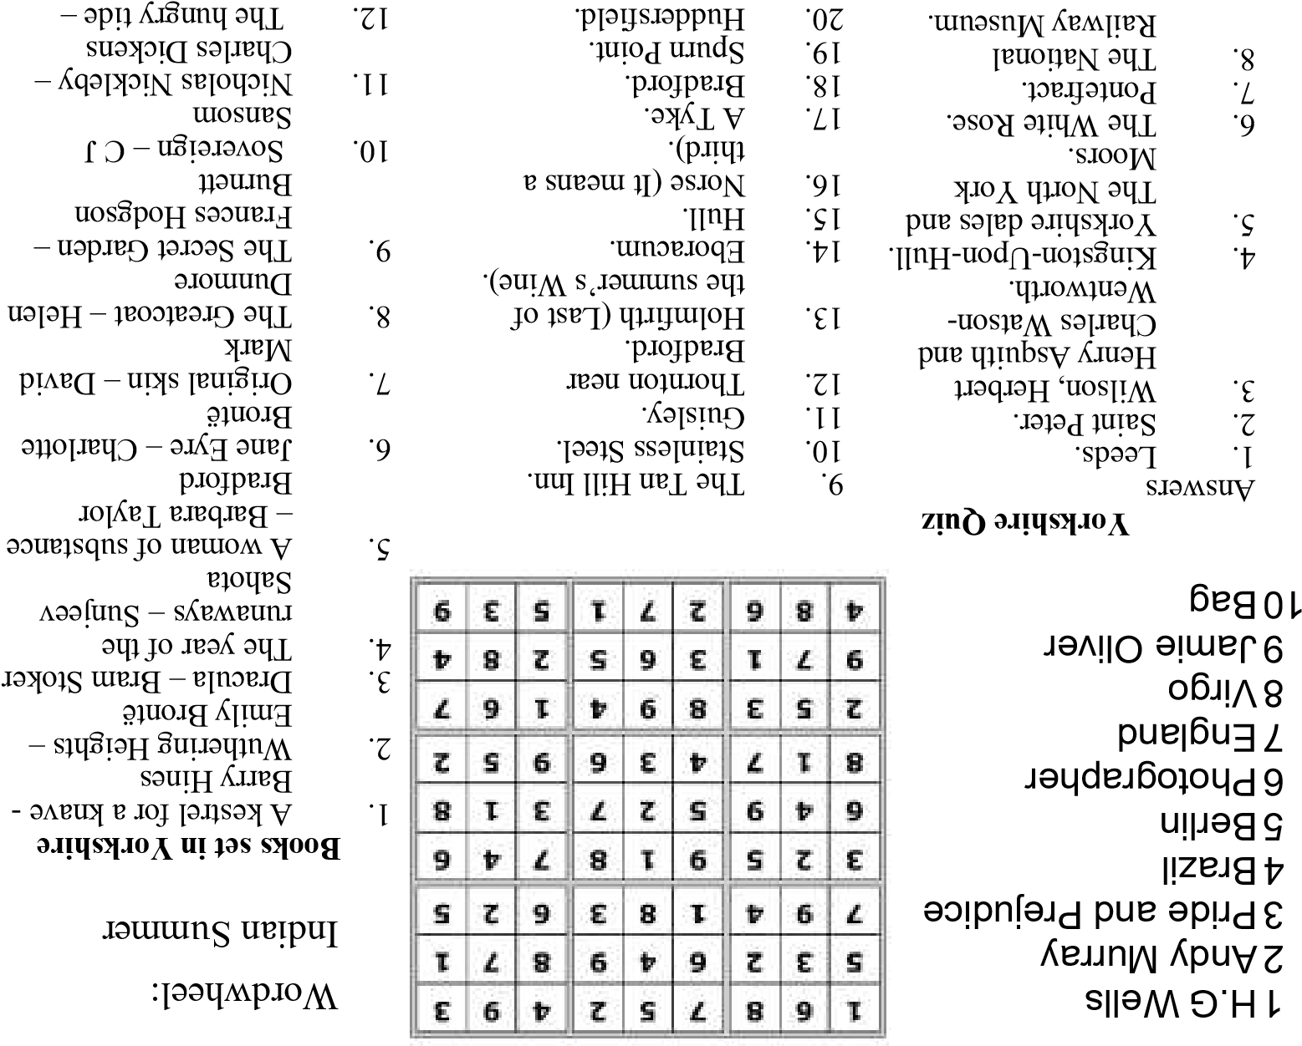
Advertising Feature

Advertisements
Advertisement
Advertising Feature
Regular group activities

Weekly Groups
Monday Pilates 6.00-7.00pm Village Hall Tuesday YCA 2.00-2.40pm Zoom
Wednesday Line Dancing 7.30-9.00pm Village Hall
Thursday Middleton Movers 2.00-3.30pm Village Hall

September
- Litter Picking Wombles 10.00am Lime View
- Parish Council 7.00pm Reading Rooms
- Village Hall Committee 7.00pm Village Hall
14 Book Group 2.00pm St Andrews Close
23 YCA “Ladies in Pigs” 7.30pm Village Hall

LOCAL CONTACTS Bell Ringing Chris Atkin |  | 217285
Book Group/Middleton Movers | Lyn Dennis | 219500
Bowls Club | Rob Bradley | 217435
Country Women’s Association | Christine Johnson | 217374
First Responders | Chris Brent | 219469
Line Dancing | Pat Pottage | 217516
Methodist Chapel | Jane Gray | 07870 562455
Middleton Messenger | Mike Kelly | 07713 620912
 | Lyn Dennis | 219500
 | Tina Walker | 217242
Middleton Womblers | Andrew Naylor | 219072
Parish Clerk | Sandra Morrison | 01262 470496
Pilates | Ian Stephenson | 07973 755717
Reading Rooms | Kath Bentley | 217456
Recreation Club | Dave Newlove | 07901 833784
St Andrew’s Church | Rev Jane Anderson | 219471
St Andrew’s Church Warden | Roger Lowe | 217656
Table Tennis | Louise Newlove | 217801
Village Hall | Lyn Dennis | 219500
Village History | Geoff Wisher | 217517

